**Chapter 3 Summary**

**INFORMATION SYSTEMS HARDWARE**

**Understanding Computer Hardware:** Computer hardware comprises the tangible components of a computer system. These include input devices like keyboards, mice, and trackpads, output devices such as screens, printers, and speakers, and storage devices for long-term data retention. Each of these components serves a specific purpose within the broader information system framework.

**Input Devices:**

* **Keyboards and Pointing Devices:** Keyboards are primary input devices for textual data entry. Pointing devices like mice and trackpads offer more intuitive ways to interact with graphical interfaces.
* **Network Connections:** Network connections facilitate input by allowing data exchange with external systems. This is crucial for online interactions, data retrieval, and remote device control.

**Output Devices:**

* **Screens, Printers, and Speakers:** Screens display visual information, printers produce hard copies of documents, and speakers provide audio output. These devices cater to diverse user preferences and accessibility needs.
* **Specialized Output Devices:** Various specialized devices like bill dispensers, gate control systems, and fuel injectors receive output data from computers, enabling automation and seamless operation in different environments.

**Storage Devices:**

* **Long-Term Storage:** Long-term storage devices, often referred to as secondary storage, store data persistently. Examples include hard drives, solid-state drives, and cloud-based storage solutions. These devices are crucial for preserving vast amounts of data over extended periods, ensuring data availability and integrity.

**Peripheral Devices and Central Electronics:**

* **Peripheral Devices:** Input, output, and storage components are collectively known as peripheral devices. They surround a computer system and interact with the central electronics.
* **Central Electronics:** The central electronics, situated within the computer's main enclosure, coordinate the activities of peripheral devices. These electronics include circuits for data manipulation, processing, and short-term storage, ensuring efficient functioning of the entire system.

**Integration with Information Systems:**

* **User Experience:** The hardware components significantly impact user experience. Devices must be compatible, responsive, and ergonomic to enhance user productivity and satisfaction.
* **Business Decision Making:** Understanding the hardware ecosystem is vital for businesses. Decision-makers need to ensure that the chosen hardware aligns with organizational needs, enabling seamless operations and effective communication.

**Evolution and Adaptability:**

* **Technological Advancements:** Ongoing technological advancements continually shape computer hardware. Miniaturization, enhanced processing power, and increased storage capacities empower information systems to handle complex tasks and vast datasets.
* **Adaptability:** Hardware components need to adapt to evolving software requirements. For instance, mobile devices require hardware capable of supporting resource-intensive applications and responsive touch interfaces.

**Future Considerations:**  
As technology advances, novel hardware interfaces, quantum computing, and bioinformatics-based computing could revolutionize the way information systems operate. Professionals need to stay abreast of these developments to harness their potential for organizational growth and innovation.

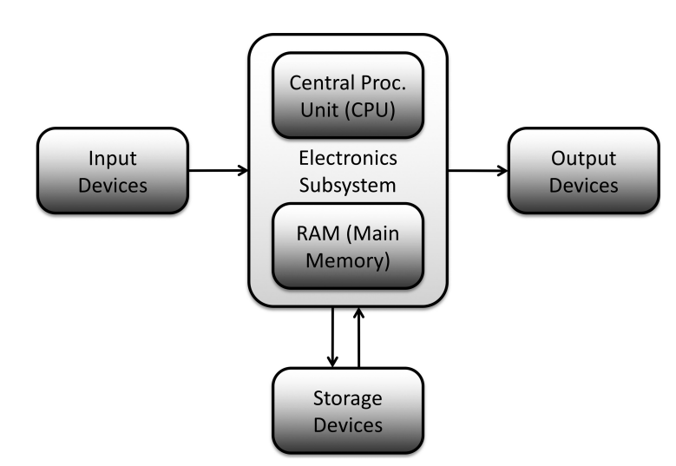

**Switches as Fundamental Units:**

* **Physical Variations:** Switches exist in various forms, such as magnetized spots on magnetic disks, non-reflecting pits on optical disks, circuit elements at different voltages in electronic components, or on/off lights in fiber optic cables.
* **Binary Representation:** Switches have two states: on or off. This binary nature forms the foundation of digital data representation.
* **Bit:** A single switch represents a binary digit, commonly known as a bit. It can be either 0 or 1, representing the two possible states of a switch.

**Data Representation Using Bits:**

* **Complex Data Representation:** Complex data, like letters of the alphabet, are represented using multiple bits. For example, 5 bits can represent 32 different combinations, allowing representation of letters A to Z.
* **Bit Combinations:** Increasing the number of bits exponentially increases the possible combinations. For instance:
  + 4 bits = 2^4 = 16 combinations (suitable for digits and some characters)
  + 8 bits = 2^8 = 256 combinations (enough for Latin-based characters and more)
  + 16 bits = 2^16 = 65,536 combinations (suitable for complex character sets like in Asian languages)

**ASCII Character Set:**

* **Original 7-Bit Set:** ASCII initially had 128 characters in a 7-bit set, with 96 printable characters and 32 control characters.
* **Expansion to 8 Bits:** Realizing the limitations, an extended ASCII set was created, adding 128 more characters. This set accommodated accented letters and additional symbols.
* **Byte:** An 8-bit combination is called a byte, representing a character, a number, or part of a larger data set. Bytes are the basic unit of computer data today.

**Data Storage and Metric System Prefixes:**

* **Data Sizes and Storage Units:** Data storage requirements vary significantly. Metric system prefixes (e.g., kilobyte, megabyte) are used to describe large amounts of data storage.
* **Examples of Data Sizes:** Different types of data occupy varying amounts of storage space:
  + Typical word: About ten bytes
  + Low-resolution photo: 100 KB
  + Thirty-minute TV show in high definition: 500 MB
  + All the words ever spoken by human beings: 5 EB (exabytes)

**Significance in Information Systems:**

* **Understanding Terminology:** Knowledge of computing terminology, including binary representation, bits, bytes, and storage units, is vital for effective communication in the field of information systems.
* **Capacity Planning:** Professionals must comprehend data storage requirements to plan and manage information systems effectively, ensuring sufficient storage capacity for organizational needs.

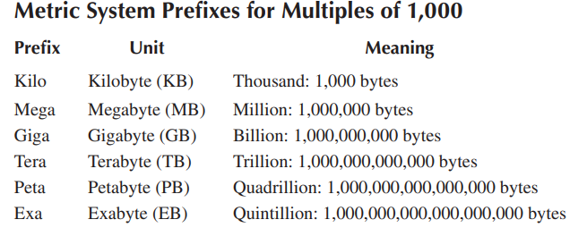

1. **CPU Functionality:**
   * The CPU is the core component of a computer, responsible for executing instructions and controlling all activities.
   * It processes calculations and translates results into visual outputs on the screen, such as displaying numbers or patterns of dots.
   * Instructions for the CPU are stored in the computer's main memory and are represented as sequences of bits.
   * Different sequences of bits represent different operations. For example, "00000001" might mean "add two numbers," and "11101001" might signify "subtract."
2. **Instruction Sets:**
   * The sequence of bits representing instructions is arbitrary and determined by the computer's instruction set.
   * An instruction set is a specific collection of instructions that a CPU can execute.
   * Different instruction sets exist, such as Intel and ARM, and software is designed to run on specific instruction sets. Software written for one instruction set will not work on a CPU with a different instruction set.
3. **Compatibility and Software:**
   * Software compatibility is crucial because software is bound to a specific instruction set.
   * Applications are tailored to work with a particular instruction set; using the wrong instruction set will render the software unusable or ineffective.
   * Businesses need to choose computers that support the necessary instruction set for their required software applications.
4. **Complexity of Programming:**
   * Creating programs involves intricate combinations of thousands or millions of instructions.
   * Each instruction handles a small part of a task, and programmers must intricately sequence these instructions to perform complex operations like word processing, gaming actions, or email communications.

Understanding the connection between software and instruction sets is essential for businesses and users to ensure that the software they rely on can function properly on their chosen computer systems.

1. **Rotating Magnetic Disks:**
   * **Description:** Magnetic disks consist of platters coated with a magnetizable alloy. Data is recorded using read/write heads that magnetize spots on the surface, representing 0s and 1s.
   * **Types:** Internal drives (inside the computer) and external drives (attached to the computer).
   * **Capacity:** Varies from a few TBs to 20 TB.
   * **Speed:** Transfer speed depends on the connection type (e.g., SATA).
   * **Portability:** External drives can be portable or require a power supply.
   * **Advantages:** Relatively low cost, high capacity, and standard interfaces.
   * **Note:** Dust particles can damage drives, especially high-capacity ones with tight tolerances.
2. **Optical Disks:**
   * **Description:** Optical disks have pits burned into a reflective surface to represent data. A low-powered laser reads the pits as 0s and 1s.
   * **Types:** Read-only (e.g., commercial software), writeable (can be written once), and rewriteable (can be erased and rewritten).
   * **Speed:** Access time is higher than magnetic disks (in tenths of a second).
   * **Portability:** Removable disks; data can be archived on shelves of disks.
   * **Advantages:** Long-term data storage, non-volatile, removable storage medium.
3. **Solid-State Storage:**
   * **Description:** Solid-state drives use non-volatile technologies with no moving parts for data storage.
   * **Applications:** Used in laptops, smartphones, tablets, and enterprise-level storage systems.
   * **Advantages:** Fast access times, no moving parts (less prone to physical damage), becoming more affordable due to decreasing costs.
4. **Magnetic Tape Storage:**
   * **Description:** Magnetic tape storage uses magnetic tape cartridges for data storage.
   * **Capacity:** LTO-8 standard allows 12 TB of data storage; upcoming technology promises 330 TB in a palm-sized cartridge.
   * **Use Cases:** Data backup, archival storage, large data transfers, and loading applications into computers.
   * **Advantages:** Low cost, high capacity, and high transfer speed for large-scale data operations.

Each type of secondary storage device has its own advantages and use cases, catering to different storage needs and requirements.

**Enterprise Storage Subsystems:**

**RAID (Redundant Array of Independent Disks):**

* **Purpose:** RAID systems combine multiple disk drives with electronics to mimic a single drive, offering increased capacity, improved speed, and data redundancy.
* **Data Protection:** RAID systems can protect against data loss by duplicating data across multiple drives. For example, in RAID Level 5, data is distributed across several drives, with parity information used for data recovery if a drive fails.
* **Types:** Different RAID levels offer varying features. RAID Level 5, for instance, balances cost and data protection, providing good performance and acting like a single drive with increased capacity.

**NAS (Network-Attached Storage):**

* **Functionality:** NAS systems address the issue of individual disk drives being designed for single computers. Disk drives in a NAS attach to a specialized computer inside the NAS, allowing multiple computers to access data over a network.
* **RAID in NAS:** NAS subsystems can use RAID configurations, providing advantages like increased storage capacity and data protection.

**SAN (Storage-Area Network):**

* **Definition:** SAN is a self-contained system that includes storage and specialized computers managing storage. SANs provide high-speed network access to storage devices.
* **Benefits:** SANs offer storage to connected computers as if it were their own, handle management tasks, optimize storage usage, and manage backup and recovery processes.
* **Connectivity:** SANs often use fiber optic links, enabling them to cover long distances and support large data centers.

**Cloud Storage:**

* **Access and Technology:** Cloud storage refers to storing data on remote servers accessed over the Internet. Data is sent to a third-party company, which stores and manages it on their storage devices.
* **Advantages:** Cloud storage benefits from economies of scale, professional administration, backup services, and accessibility from anywhere with an internet connection.
* **Disadvantages:** Concerns include potential loss of control, security risks, overhead costs for providers, and potential slower access speeds compared to local storage.

**Input Devices:**

* **Diversity:** Input devices vary widely, including keyboards, pointing devices, cameras, scanners, motion sensors, specialized task-specific devices, and communication links (GPS, RFID).
* **Evolution:** New input devices constantly emerge, like eyeglass-mounted devices, making it essential to be open to innovative tools.

**Output Devices:**

* **Displays:** Display technologies include LCD and LED screens, projectors, and specialized devices like virtual reality headsets.
* **Printers:** Printers come in toner-based (laser) and ink-based varieties, with considerations such as resolution, speed, features, and cost being crucial factors.
* **Other Devices:** Output devices also include speakers, haptic or tactile feedback devices, and various electronically driven tools.

**Key Considerations:**

* **Trade-offs:** Decision-making involves evaluating multiple factors simultaneously, considering the trade-offs among desirable features.
* **Creativity and Innovation:** The diversity of output devices is bound only by creativity, with the potential for inventing new devices to meet specific needs.

Understanding these storage and hardware concepts is crucial for professionals in the field of information systems, enabling effective decision-making and implementation of technology solutions.